Spelling / Grammar/ Punctuation
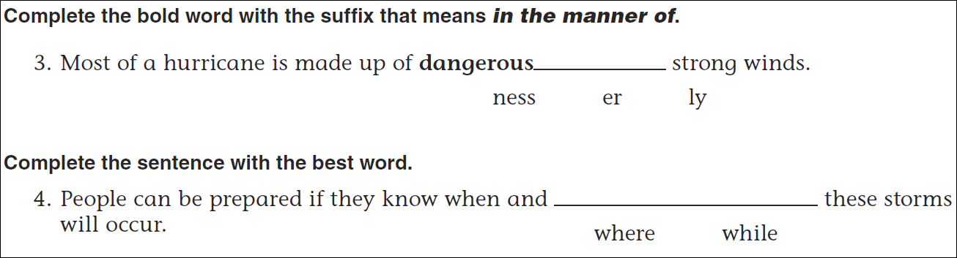
Math
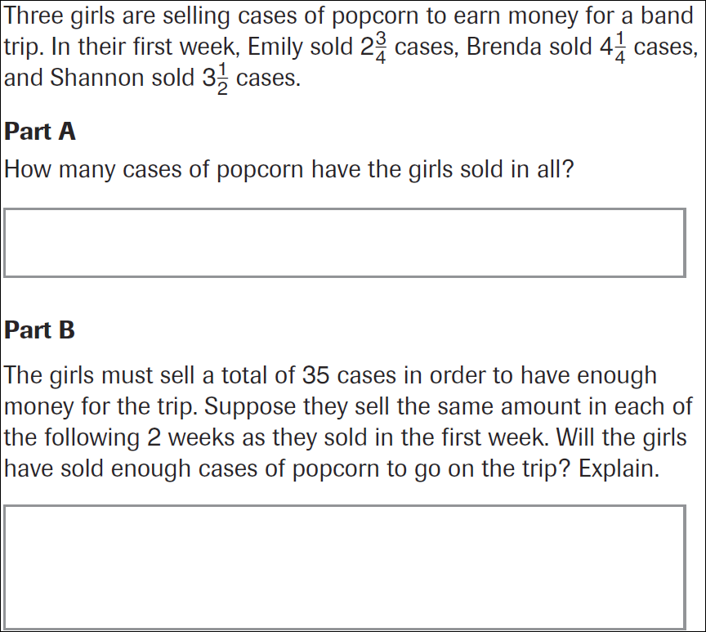
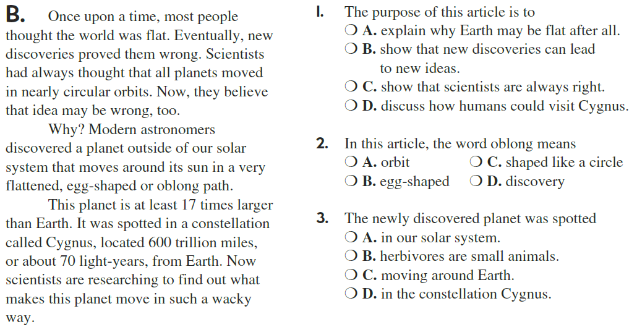

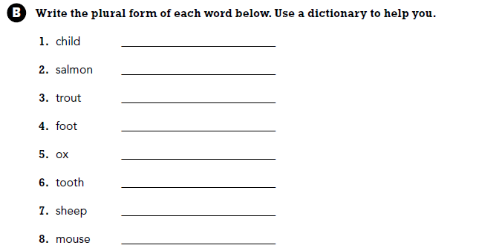

Use part of the question in your answer.
What is a fraction with a numerator of one called?

