Spelling / Grammar/ Punctuation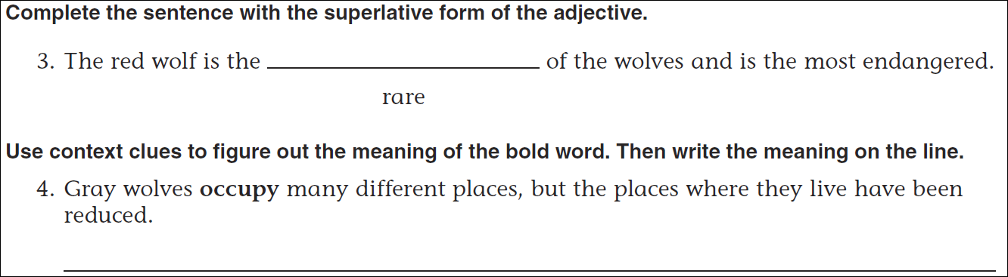
Math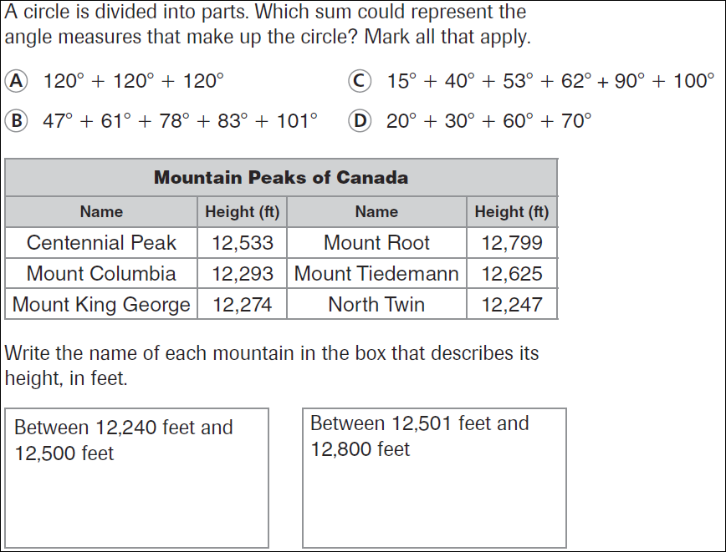
17 ÷3= | 22÷3= | 8÷3= | 26÷3=

