Spelling / Grammar/ Punctuation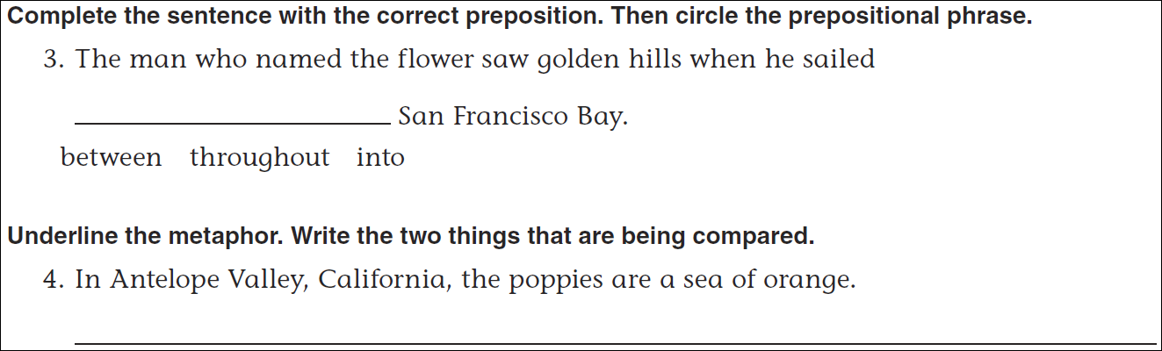
Math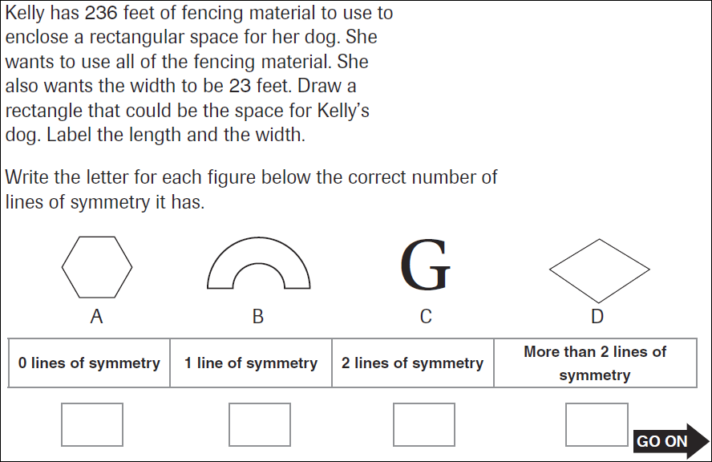
14÷6= | 24÷6= | 34÷6= | 44÷6=
14÷4= | 24÷4= | 34÷4= | 44÷4=

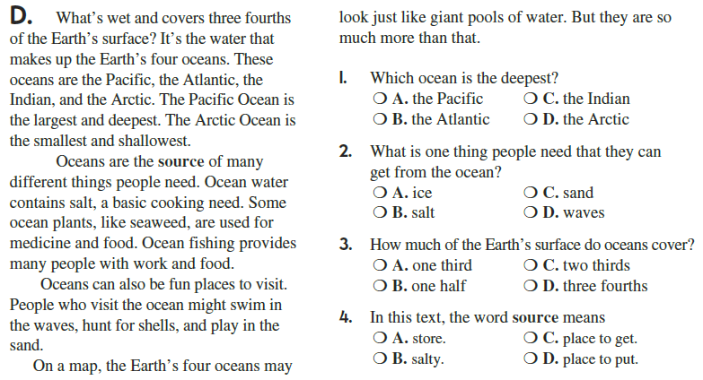

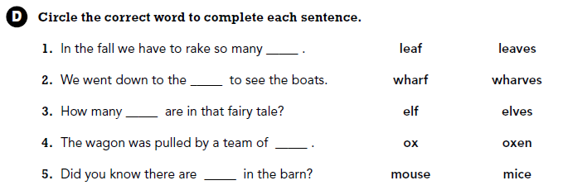

Use part of the question in your answer.
What’s it called when a fraction has a larger numerator than denominator?

