Spelling / Grammar/ Punctuation
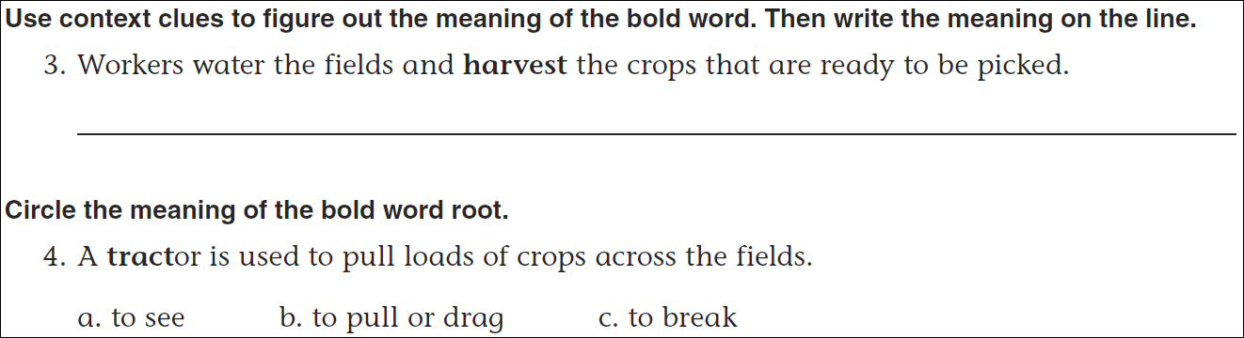
Math
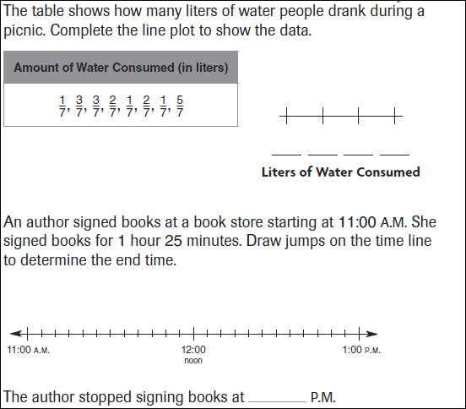
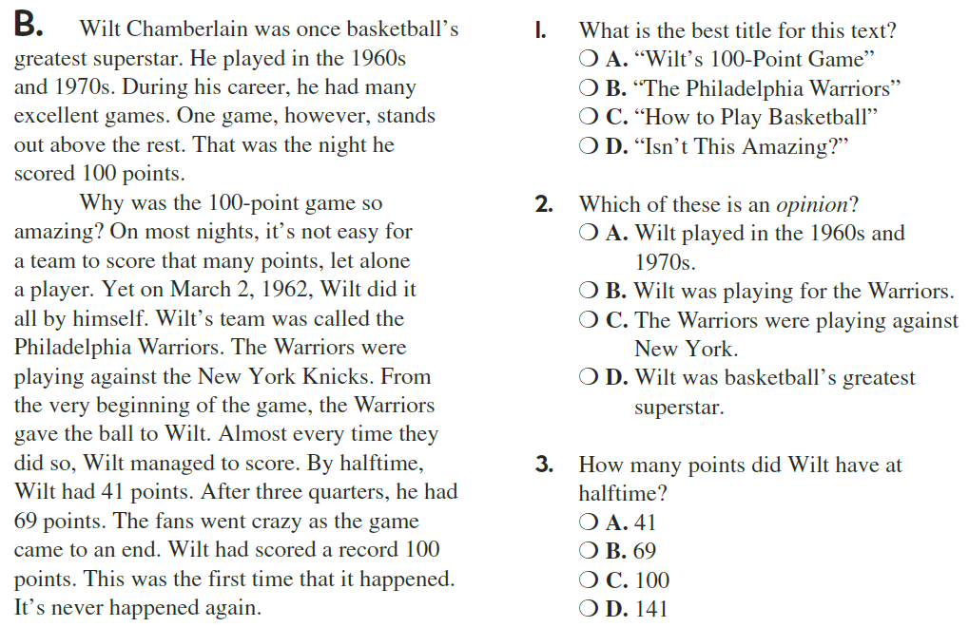
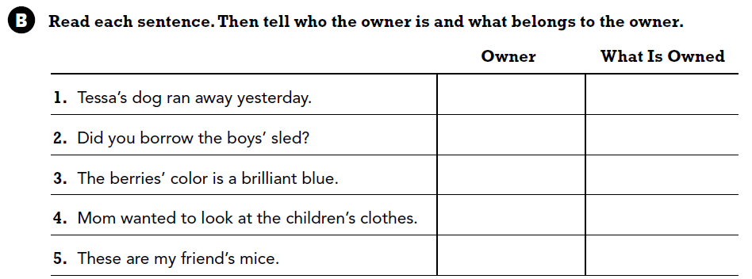

Use part of the question in your answer.
What do you do to find the perimeter of a square?

