Spelling / Grammar/ Punctuation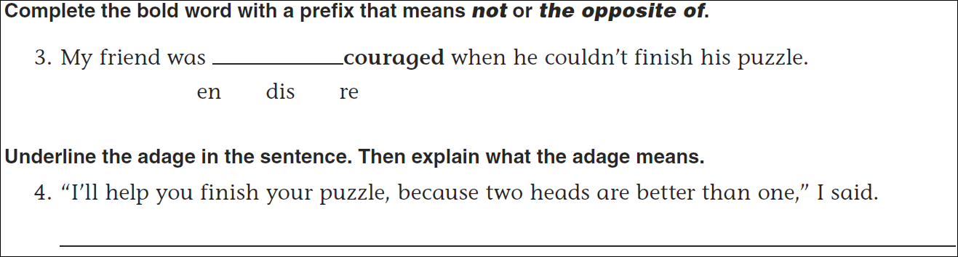
Math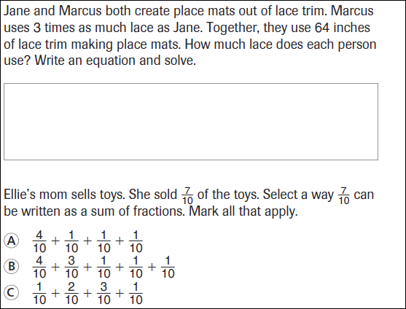
9 ÷ 4 = | 19 ÷ 4 = | 29 ÷ 4 = | 39 ÷ 4 =

