Spelling / Grammar/ Punctuation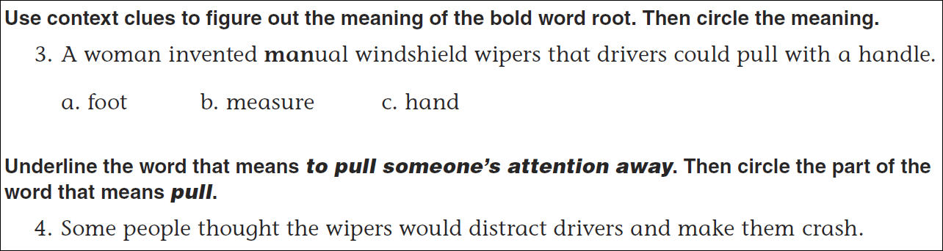
Math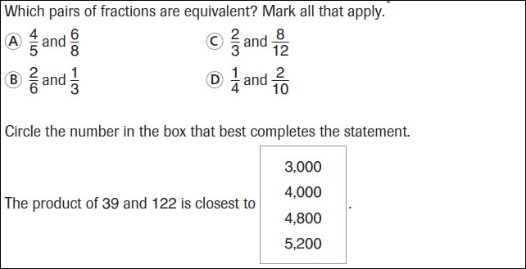

19 ÷ 6 = | 29 ÷ 6 = | 39 ÷ 6 = | 49 ÷ 6 =
19 ÷ 7 = | 29 ÷ 7 = | 39 ÷ 7 = | 49 ÷ 7 =

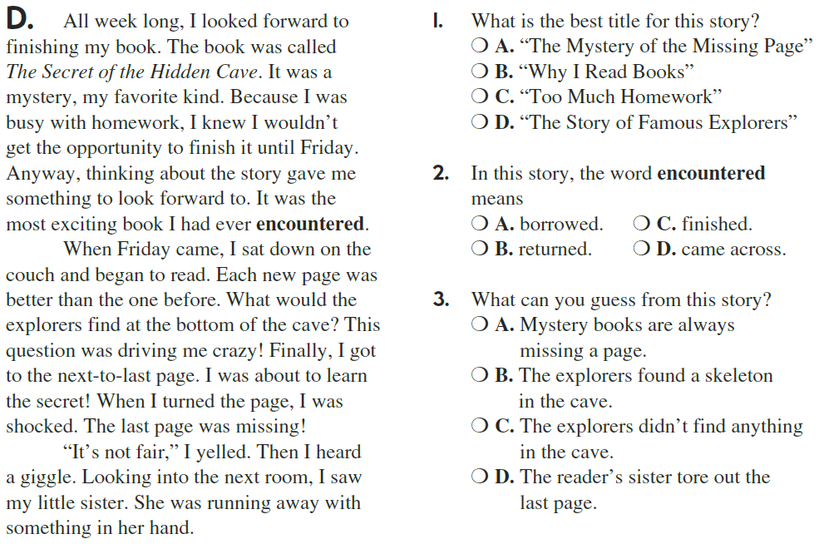
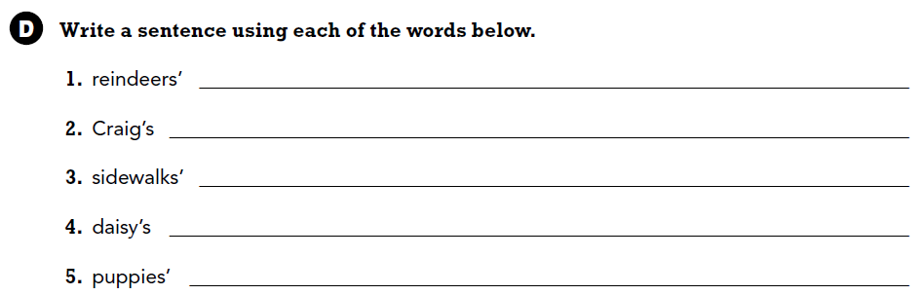

Use part of the question in your answer.
What do you do to find the area of a rectangle?

