Spelling / Grammar/ Punctuation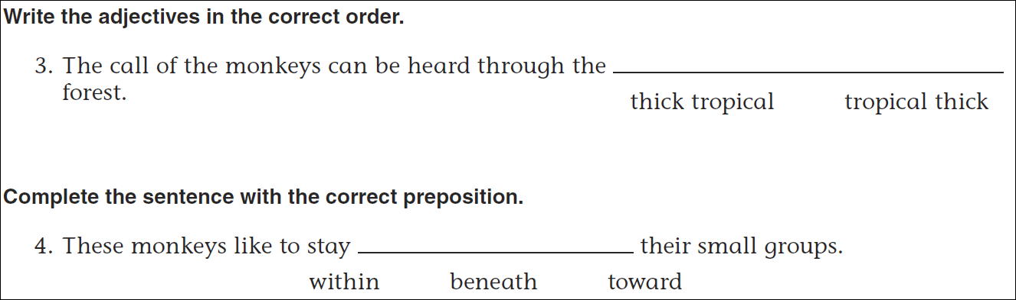
Math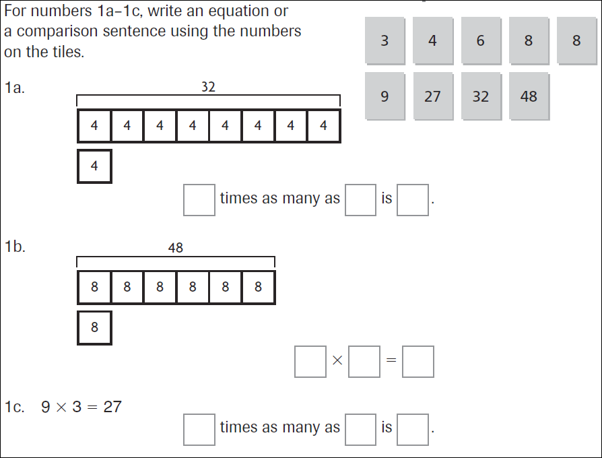
15 ÷ 4 = | 25 ÷ 4 = | 35 ÷ 4 = | 45 ÷ 4 =
