Spelling / Grammar/ Punctuation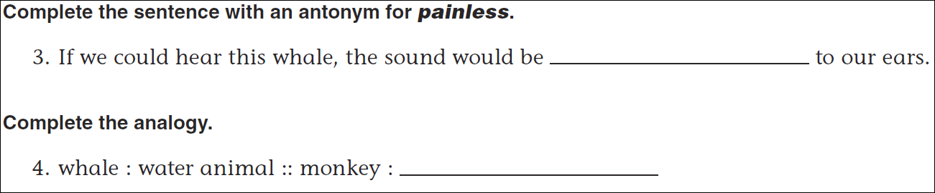
Math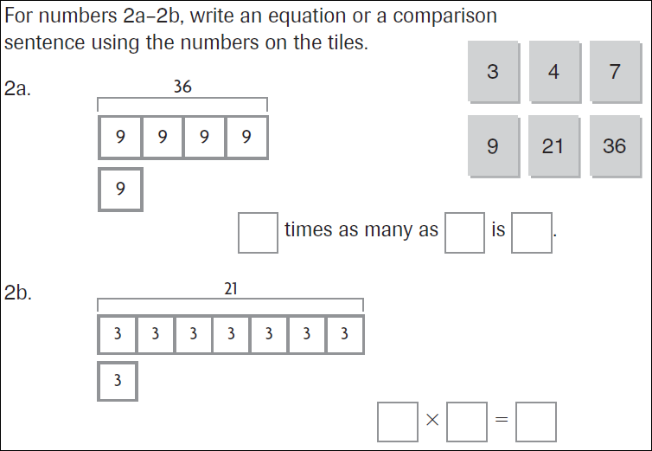

12 ÷ 5= | 22 ÷ 5= | 32 ÷ 5= | 42 ÷ 5=
13 ÷ 6= | 23 ÷ 6= | 33 ÷ 6= | 43 ÷ 6=

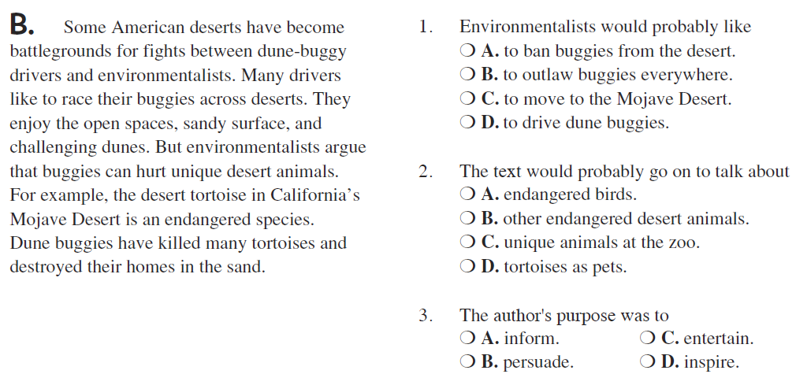

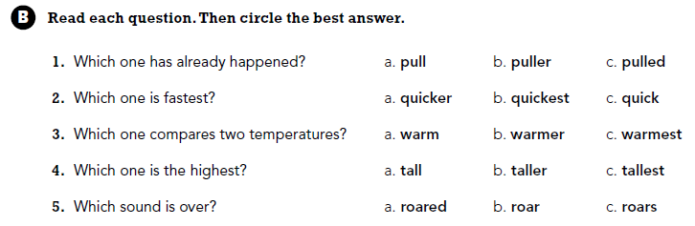

Use part of the question in the answer.
What is the difference between even and odd numbers?

