Spelling / Grammar/ Punctuation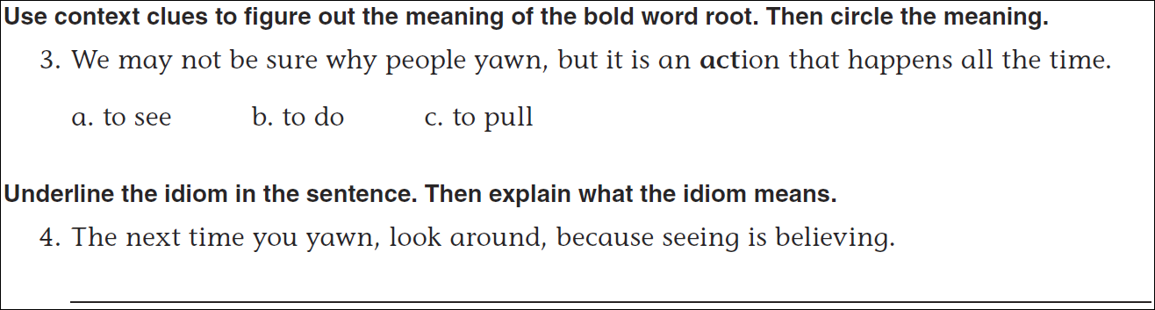
Math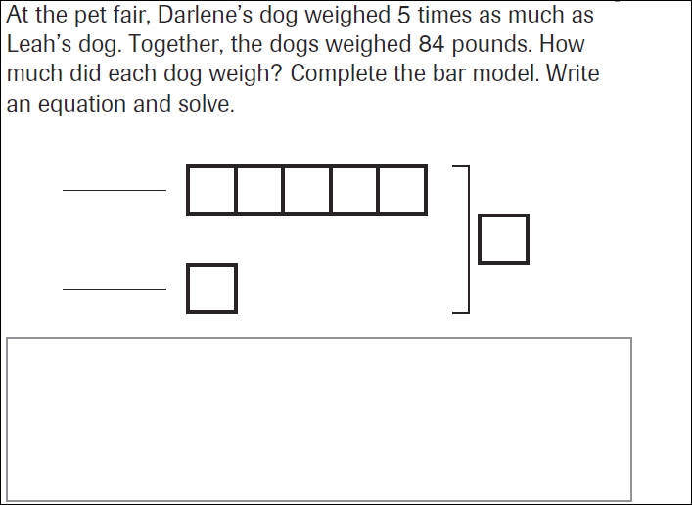
18÷7 = | 28÷7= | 38÷7= | 48÷7=
18÷8= | 28÷8= | 38÷8= | 48÷8=

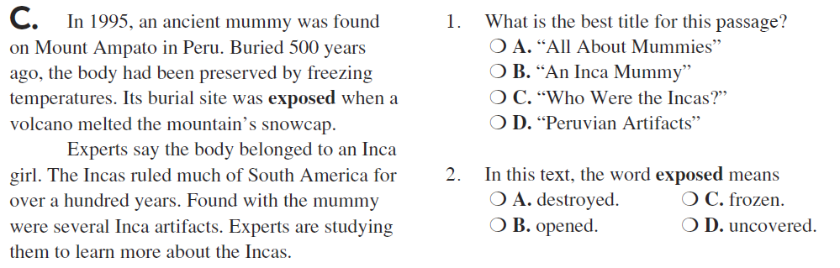

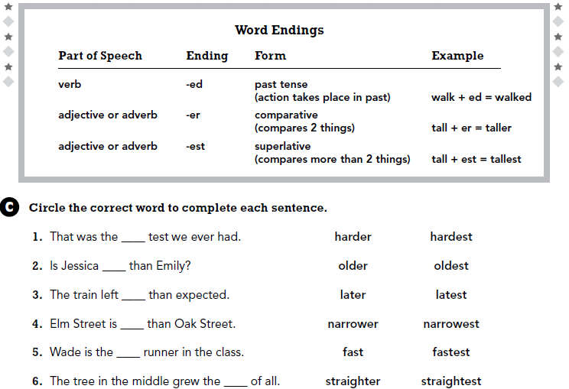

Use part of the question in your answer.
How can you tell if a number is prime?

