Spelling / Grammar/ Punctuation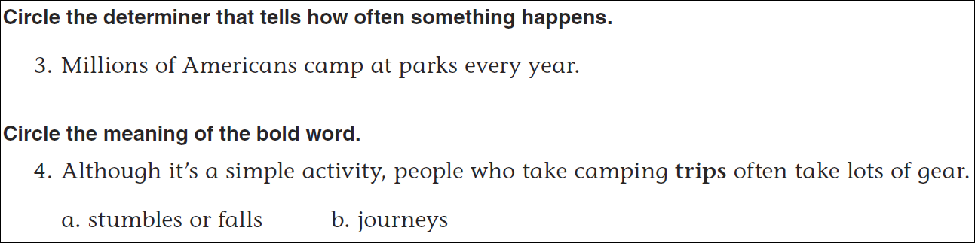
Math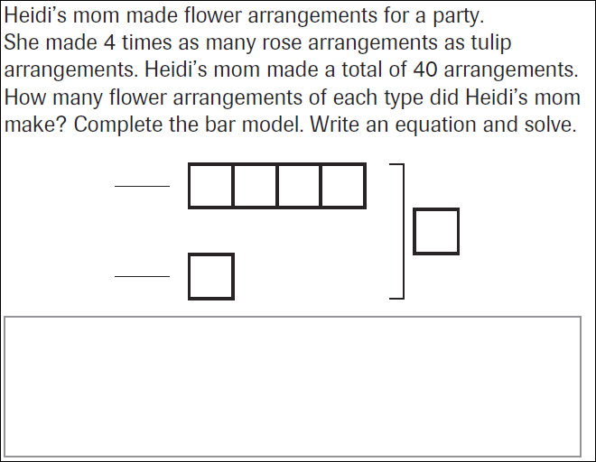
9÷5= | 19÷5= | 29÷5= | 39÷5=

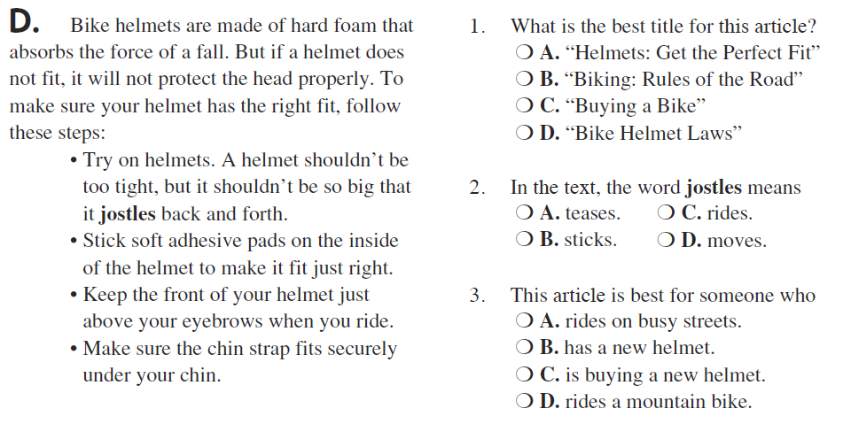

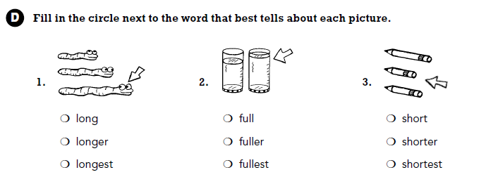

Use part of the question in the answer.
How can you tell if a number is composite?

