Spelling / Grammar/ Punctuation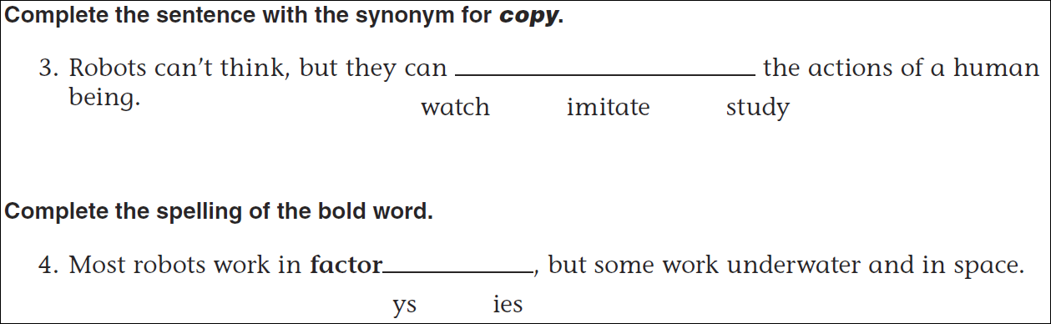
Math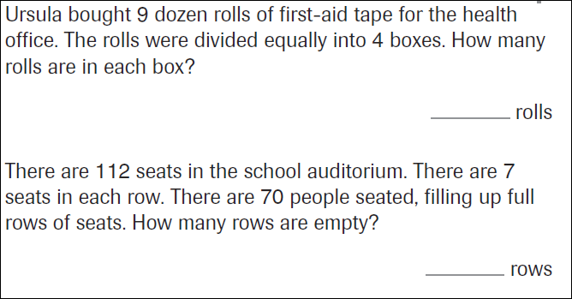

15÷6= | 25÷6= | 35÷6= | 45÷6=
15÷7= | 25÷7= | 35÷7= | 45÷7=

