Spelling / Grammar/ Punctuation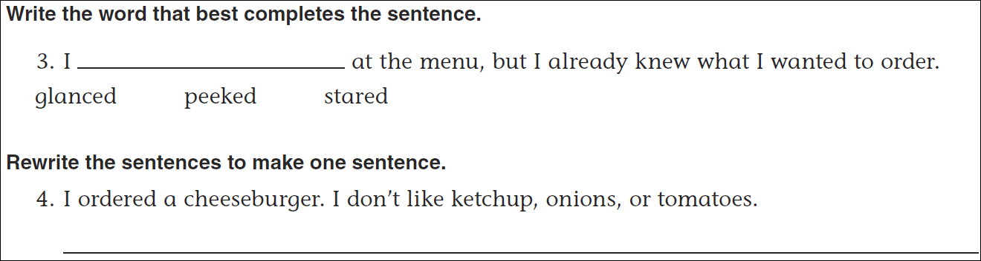
Math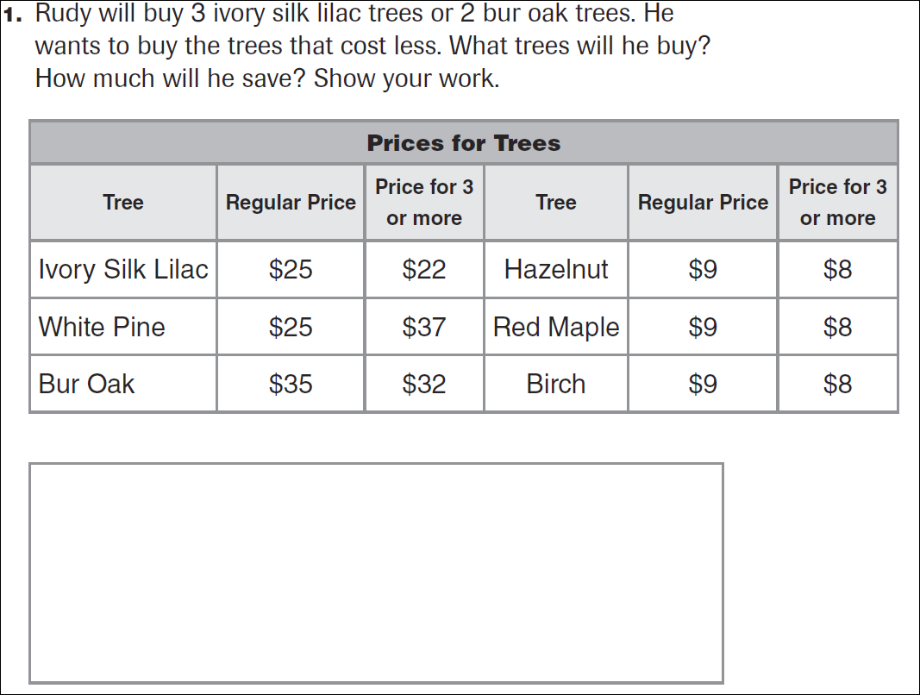
12÷5= | 22÷5= | 32÷5= | 32÷5=

