Spelling / Grammar/ Punctuation
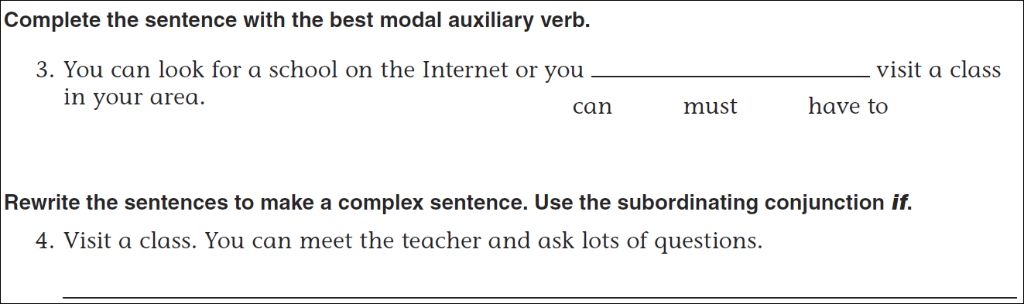
Math
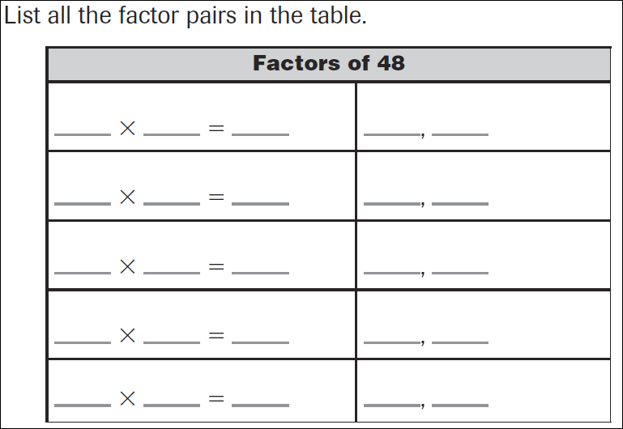
17÷8= | 27÷8= | 37÷8= | 47÷8=

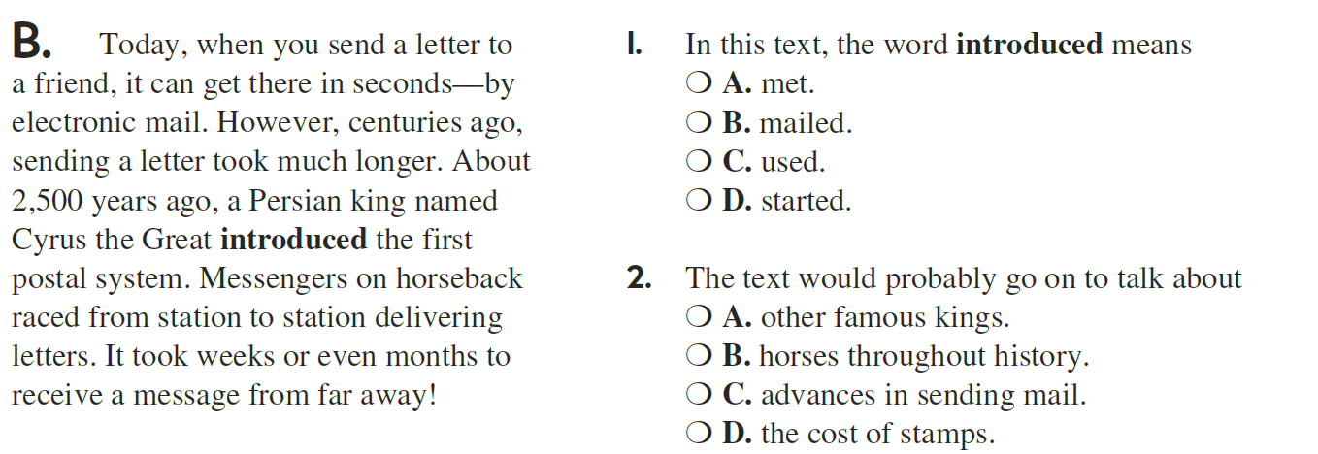

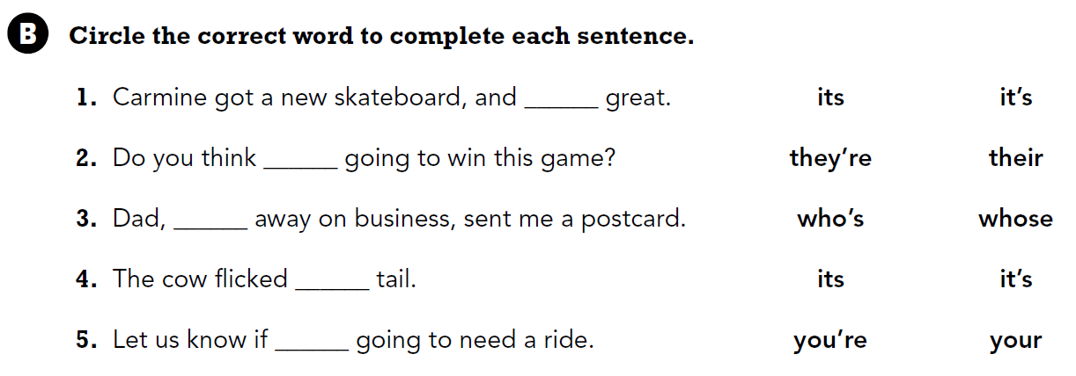

Use part of the question in your answer.
When would you use a protractor?

