Spelling / Grammar/ Punctuation
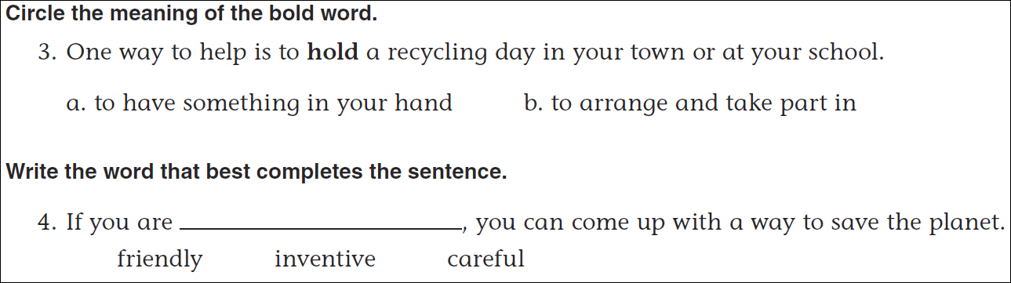
Math
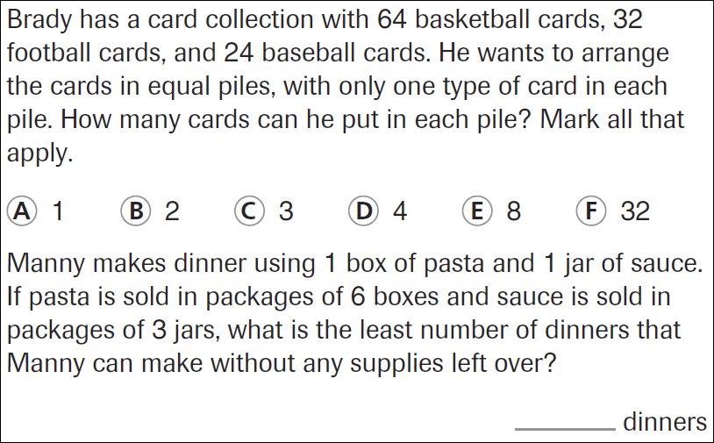

11÷6= | 21÷6= | 31÷6= | 41÷6=

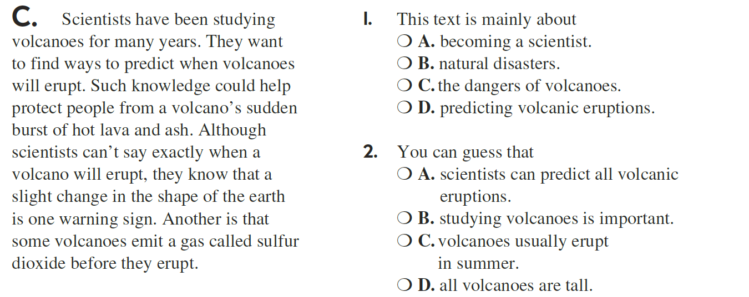

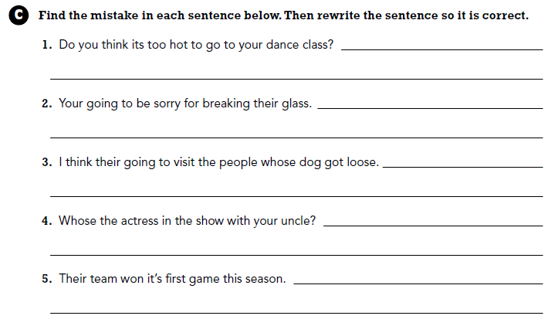

Use part of the question in the answer.
How many degrees are in a circle?

