Spelling / Grammar/ Punctuation
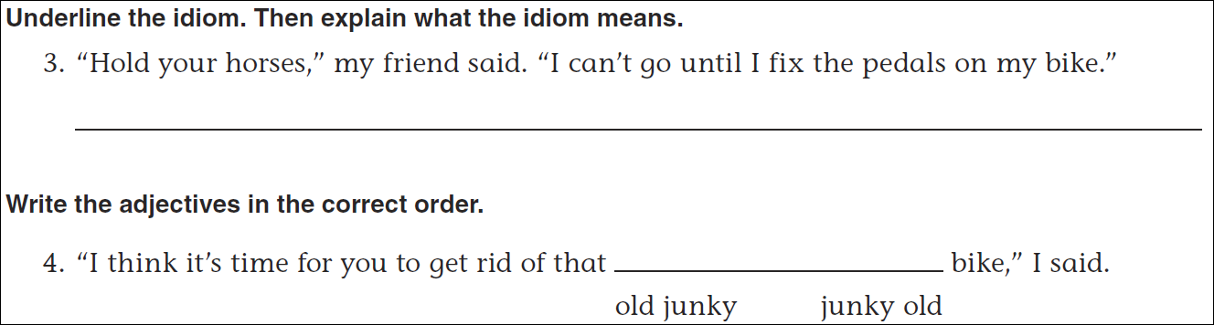
Math
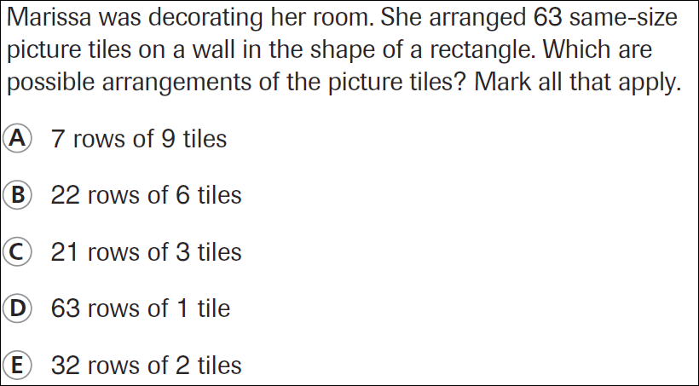

12÷7= | 22÷7= | 32÷7= | 42÷7=

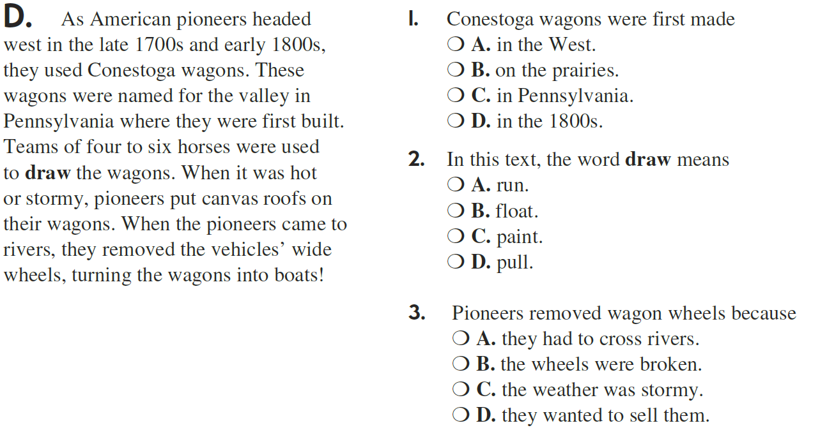

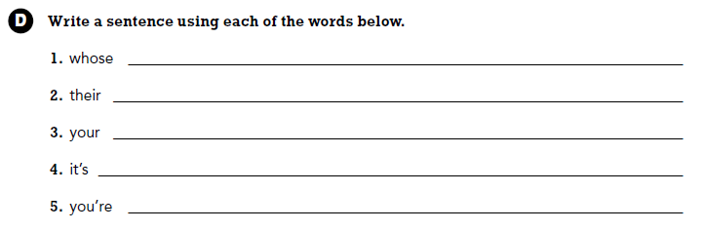

Use part of the question in the answer.
How is a protractor like a clock?

