Name____________________________________ April 21, 2023
Vocabulary ______/20 Math _______ /40 ELA ______/20 S.S. ______/20 Science _____/10

Math – Directions: Solve for each. Show your work when possible. (5 points each)
Review From This Week (See video!)
  Lesson 6.7 Video | Lesson 6.8 Video
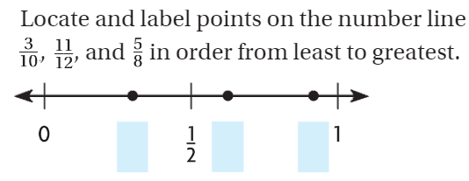 | 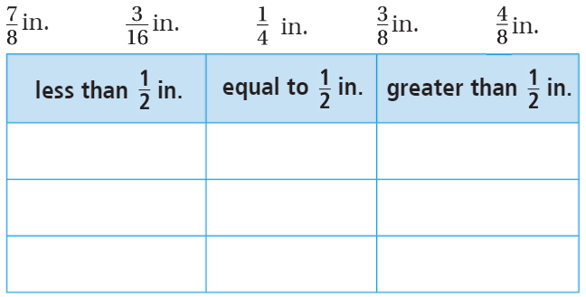

Review From This Week (See video! )
Lesson 6.2 Video | Lesson 8.1 Video
Simplify your fractions   | List the next four multiples of this fraction.  You do not need to simplify.  $\frac{5}{6}$, $\frac{}{}, \frac{}{}, \frac{}{}, \frac{}{}$
Review From This Week (See video! )
Lesson 9.6 Video | Lesson 9.7 Video
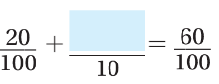 | 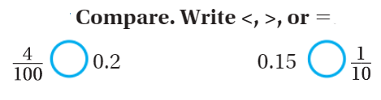

Review From This Week (See video!)
Lesson 13.3 Video – Show your work | Lesson 13.5 Video – Show your work
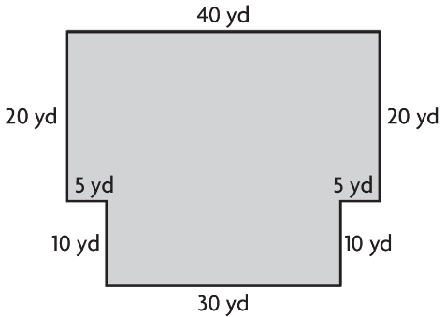  Area =________ Perimeter=________ | 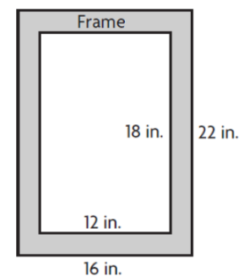  Area of the gray frame = _____
ELA/Reading (5 points each)
Conflict and Resolution
 | 1) Conflict: In yellow, highlight the section that tells you of a conflict.  2) Resolution: In blue, highlight the section that tells how the conflict was resolved.  3) Text evidence: In orange, highlight Lina’s rationale for a poodle.  4) Context Clues: What do you think compromise means?  contract  company  comparison  concession
Social Studies (5 points each) Capitalization counts! Try to spell it correctly.
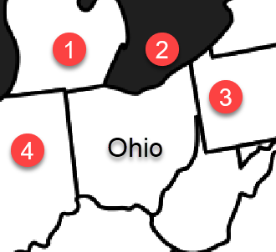 | By now, you should know all 50 states. You can use the online program Seterra to help you. For this week, look at the map to the left. This is Ohio. Name the following…  1) This state ____________________________  2) This Great Lake __________________________  3) This state ____________________________  4) This state ____________________________
Science (10 points) Write your answer in your own words.
Use part of the question. If the word is in the article, spelling counts. Capitalization and punctuation count.
Fossils are really rocks. Explain how this happens. See page 150.

Indent

