Show your work. Each is worth 2 points.
Chapter 1 Review
Round to the underlined digit   | Rename this number  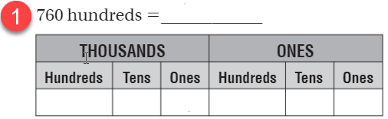
Chapter 2 Review
 | 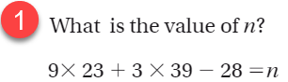
Chapter 3 Review
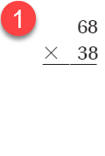 | 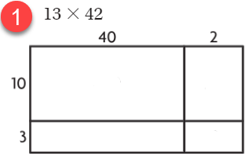
Chapter 4 Review
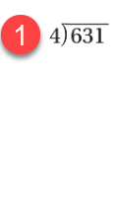 | 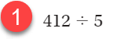
Chapter 5 Review
List the factors of 18  ____ ____ ____ ____ ____ _____ | List the multiples of 15  ____ ____ ____ ____ ____ ____ …
Chapter 6 Review
Write two equivalent fractions  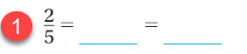 | Make same denominator equivalent fractions  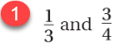
Chapter 7 Review
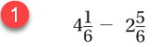 | 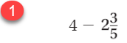
Chapter 8 Review
List the multiples of unit fractions   | Find the product  
Chapter 9 Review
Write as a fraction in hundredths  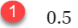 | Write as a decimal in tenths  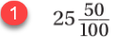
Chapter 10 & 11 Review
Name 2 parallel lines: _________________  Name 2 perpendicular lines: ___________ | 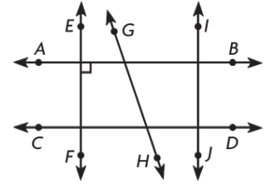
Chapter 12 & 13 Review
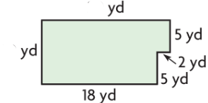 | Find the area ____________  Find the perimeter _____________
Review
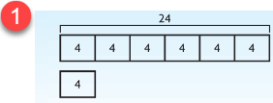  _______ times as many as _______ is ______ | 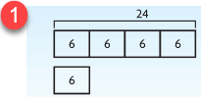  _______ is ________ times as many as _______

