I can name fractions on a number-line. 4nf1
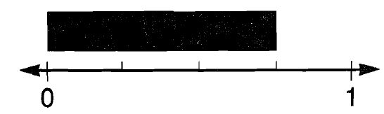
Answer:
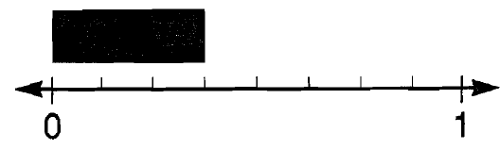
Answer:
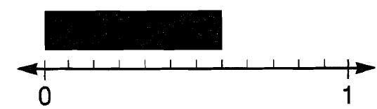
Answer:
I can place fractions on a line (thirds). 4nf3a
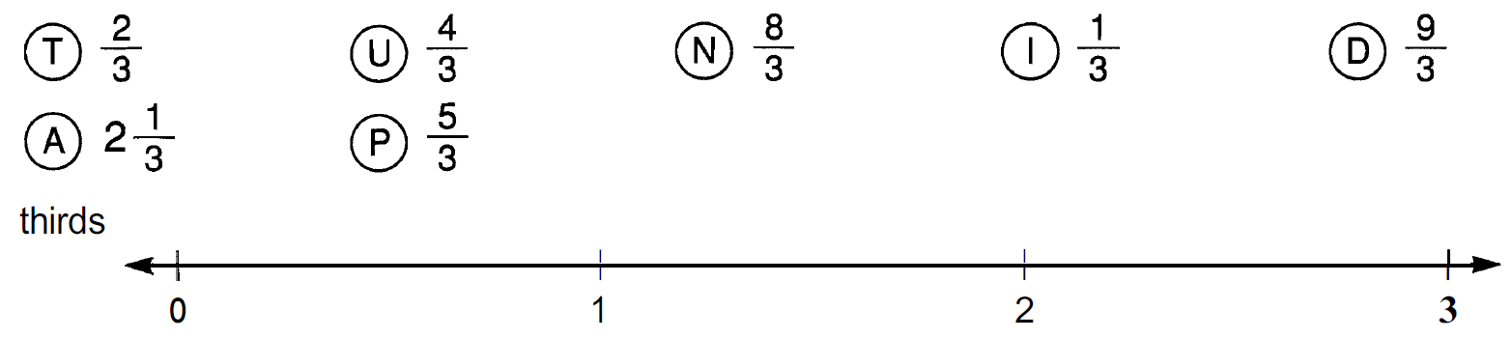
Accurately put each letter on the number-line.
I can place fractions on a line (fourths). 4nf3a
Accurately put each letter on the number-line.
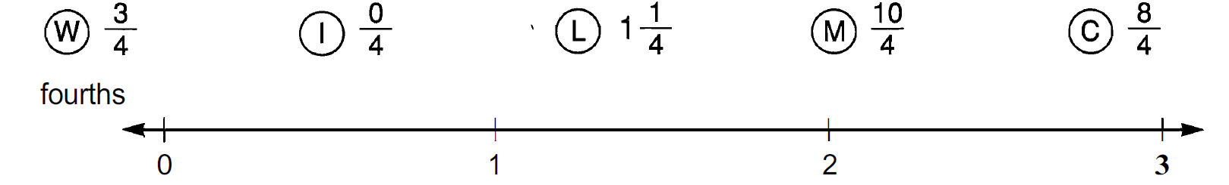
I can add mixed numbers and fix improper fractions. 4nf3c
9 $\frac{5}{8}$ + 4$\frac{7}{8}$ =  Simplify. | 5 $\frac{9}{11}$ + 6$\frac{8}{11}$ =  Simplify.

I can subtract mixed numbers with renaming. 4nf3c
13 $\frac{3}{8}$ - 6$\frac{7}{8}$ =  Simplify. | 9 – 2$\frac{7}{9}$ =  Simplify.
I can multiply whole number and mixed numbers. 4nf4b
9 x 8$\frac{1}{4}$  Simplify. | 4 x 7$\frac{5}{7}$  Simplify.

I can write models as fractions and decimals - 4NF
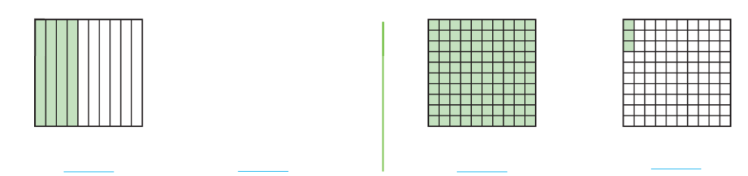
I can write mixed numbers as decimals - 4NF
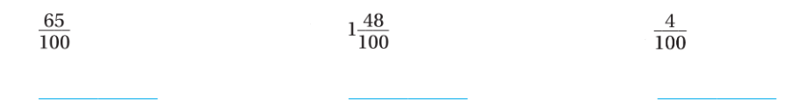
I can add tenths and hundreths and write as a decimal - 4NF
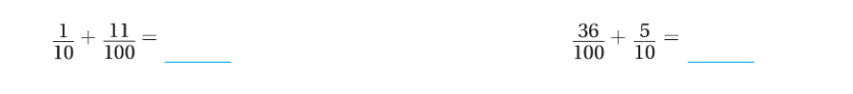
I can add tenths and hundredths - 4NF
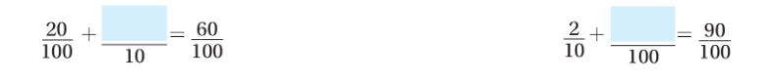
I can find parts of a decimals - (5.NBT.A.1)
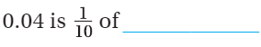 | 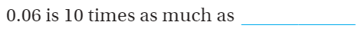
I can compare Decimals. Use <,>, or = ( 5.NBT.A.3b)
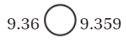 | 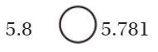
I can round decimals. Round each to the underlined digit. (5NBTA4)
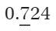  = | 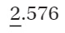  =
I can find the product of whole numbers and fractions (5NBTB7)
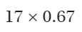 | 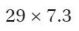
I can divide whole numbers and fractions. (5NBTB7)
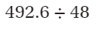 | 