I can name and LABEL lines, segments and angles using correct symbols. 4G1
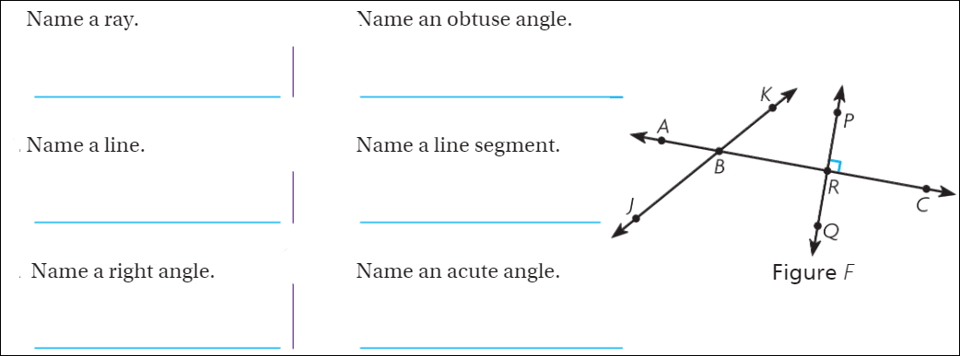
I can identify triangles based on angles. 4G2
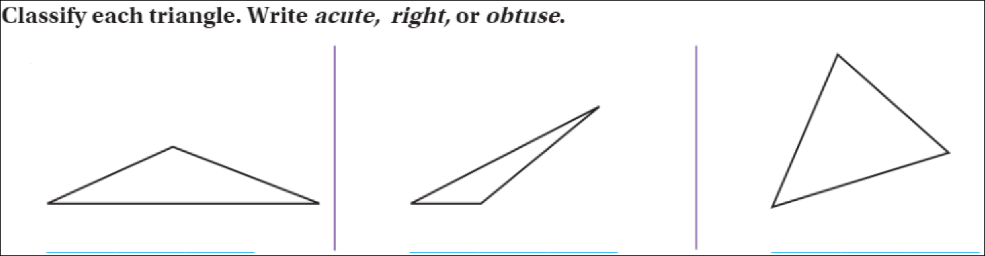
I can draw perpendicular, parallel and intersecting lines and LABEL them. 4G1
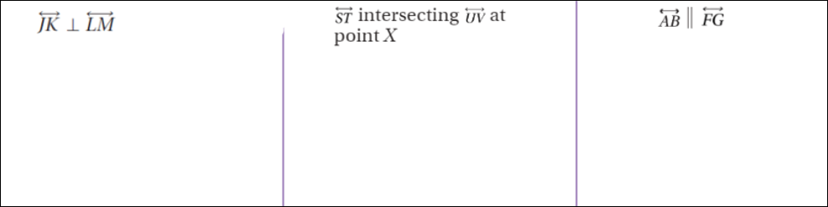
I can classify quadrilaterals based on angles and sides. 4G2
Check all that are correct.
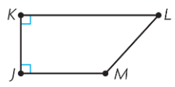  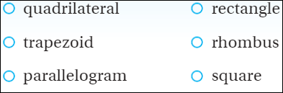 | 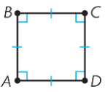 | 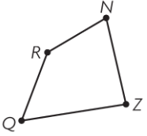

I can extend visual patterns. 4OA5
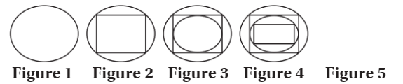
I can accurately measure angles with a protractor. 4MD5B
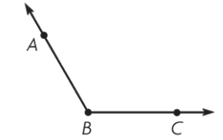 | 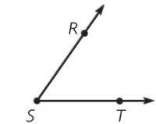
I can find unknown angles using addition and subtraction. 4MD7
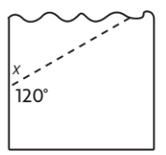 | 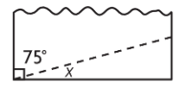
I can find the area and perimeter of polygons. 4MD3
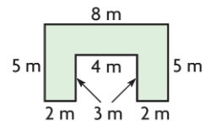  Area = ________ Perimeter=_________ | 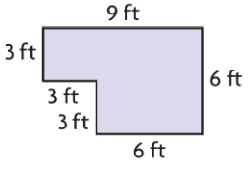  Area = ________ Perimeter=_________
I can classify triangles based on angles and sides. 5GB3
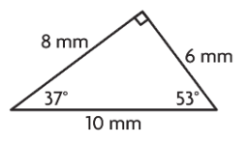
For each, write isosceles, scalene, or equilateral & then write acute, obtuse, or right.
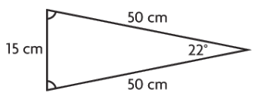
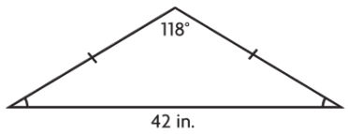

___________ ___________ ___________ ___________ ___________ ___________

I can find the volume of shapes and write the correct units. 5MDC4
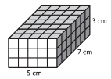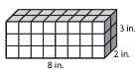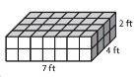
Volume = ________ Volume = ________ Volume = ________

I can find the volume of shapes and write the correct units. 5MDC5C
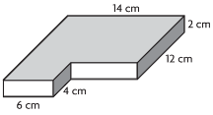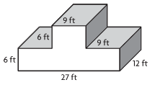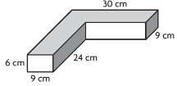
Volume = ________ Volume = ________ Volume = ________
I can write coordinates correctly. 5GA2
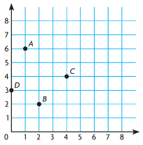 | Write the coordinates for each point:  A = ______________  B = ______________  C = ______________  D = ______________
I can convert units of measurement. 5GA2
Robert’s soccer team needs to be off the soccer field by 12:15 P.M. Each game  is at most 1 $\frac{3}{4}$ hours long. What time should the game begin to be sure that the  team finishes on time? | Edgar got out of school at 2:40. Then, 230 minutes later his dad took the chicken off the grill and they ate dinner. At what time did Edgar eat dinner?

