I can name and LABEL lines, segments and angles using correct symbols. 4G1
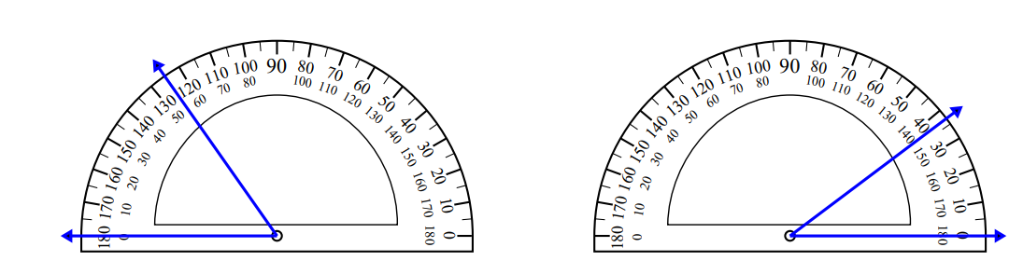
I can identify triangles based on angles. 4G2
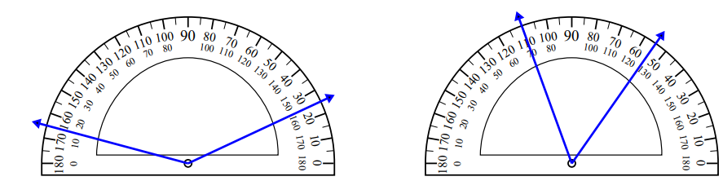
I can draw perpendicular, parallel and intersecting lines and LABEL them. 4G1
I can classify quadrilaterals based on angles and sides. 4G2
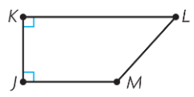  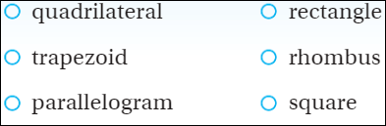 | 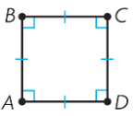 | 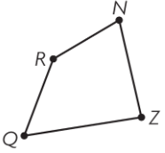

I can add mixed numbers and fix improper fractions. 4OA5
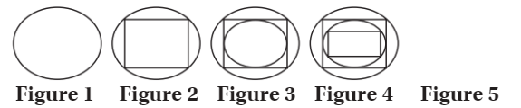
I can accurately measure angles with a protractor. 4MD5B
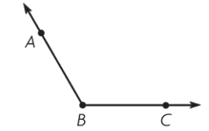 | 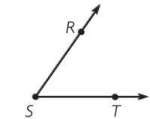
I can find unknown angles using addition and subtraction. 4MD7
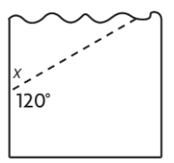 | 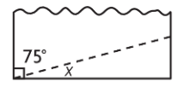
I can find the area and perimeter of polygons. 4MD3
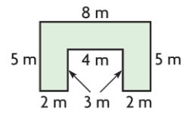  Area = ________ Perimeter=_________ | 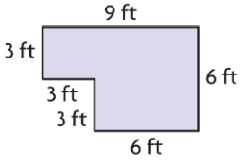  Area = ________ Perimeter=_________

