Solve the pattern.
.  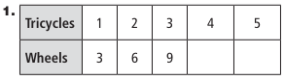 | 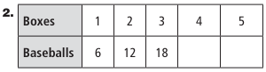
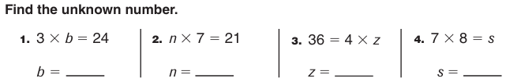

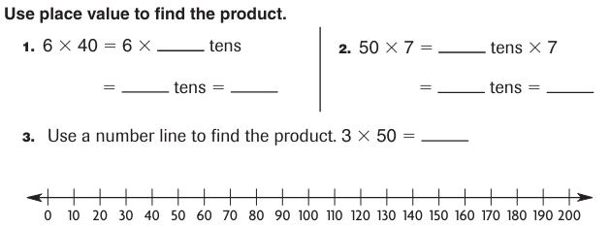
Find the product by skip counting.
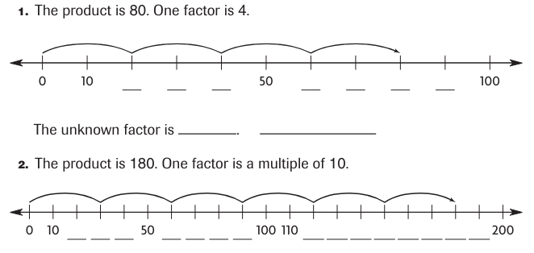

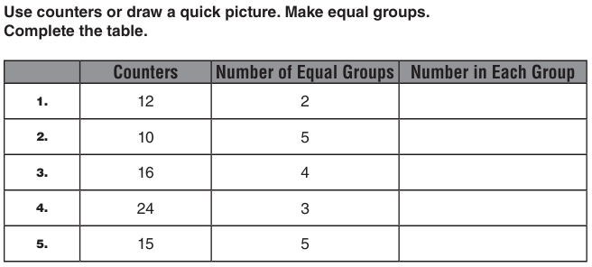

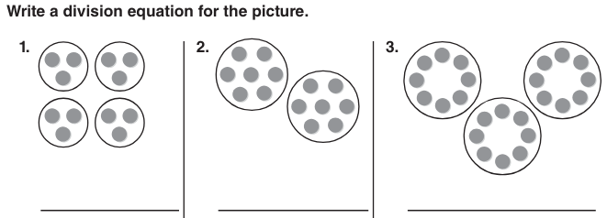

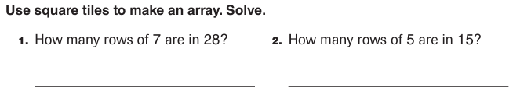

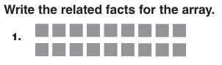  _____ x ____ = ______ _____x_____ = _____  _____÷_____ = _____ _____÷_____ = _____ | 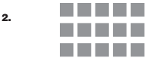  _____ x _____ = _____ _____x_____ = _____  _____÷_____ = ____ _____÷_____ = _____

