Name____________________________________ April 24, 2026
Vocabulary ______/20 Math _______ /30 ELA ______/20 S.S. ______/20 Science _____/10

Math – Directions: Solve for each. Show your work when possible. (10 points each)
Draw a model to explain this word problem. (See video!)
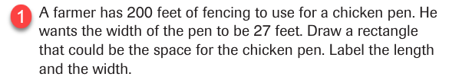

Draw a model to explain this word problem. (See video! )
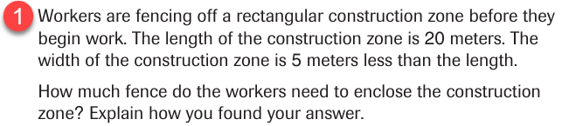

Draw a model to explain this word problem. (See video! )
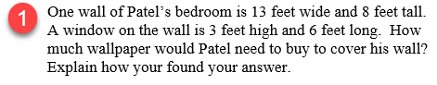

ELA/Reading (5 points each)
Conflict and Resolution
 | 1) Conflict: In yellow, highlight the section that tells you of a conflict.  2) Resolution: In blue, highlight the section that tells how the conflict was resolved.  3) Text evidence: In orange, highlight Lina’s rationale for a poodle.  4) Context Clues: What do you think compromise means?  contract  company  comparison  concession
Social Studies (5 points each) Capitalization counts! Try to spell it correctly.
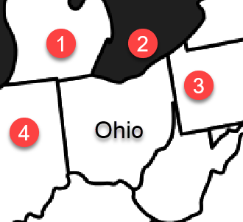 | By now, you should know all 50 states. You can use the online program Seterra to help you. For this week, look at the map to the left. This is Ohio. Name the following…  1) This state ____________________________  2) This Great Lake __________________________  3) This state ____________________________  4) This state ____________________________
Science (10 points) Write your answer in your own words.
Use part of the question. If the word is in the article, spelling counts. Capitalization and punctuation count.
Fossils are really rocks. Explain how this happens. See page 150.

Indent

