I can name and LABEL lines, segments and angles using correct symbols. 4G1
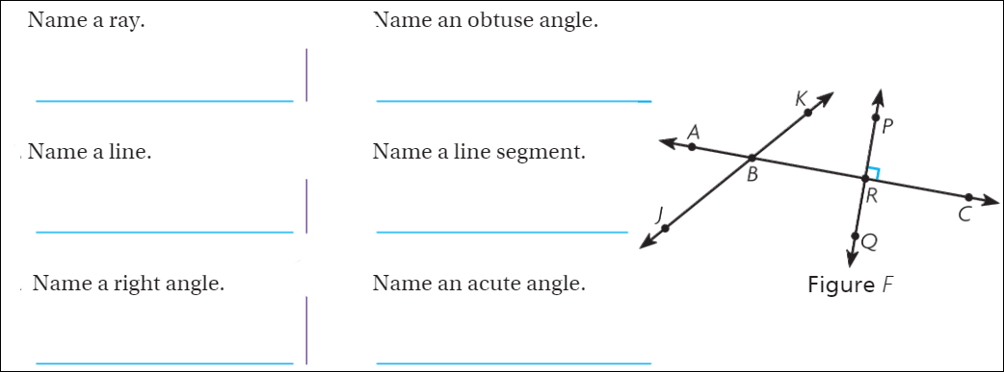
I can identify triangles based on angles. 4G2
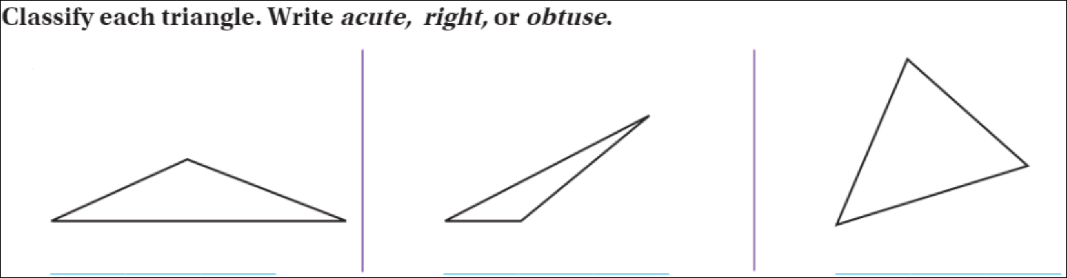
I can draw perpendicular, parallel and intersecting lines and LABEL them. 4G1
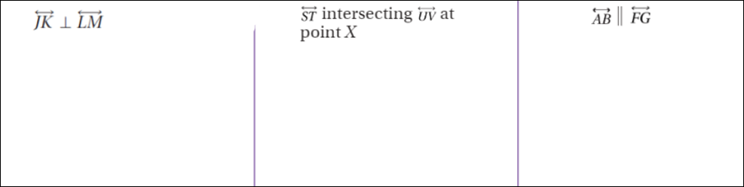
I can classify quadrilaterals based on angles and sides. 4G2
Check all that are correct.
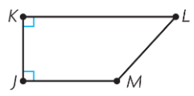  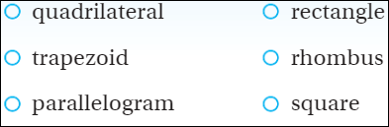 | 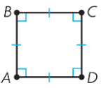 | 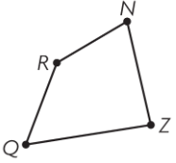

I can extend visual patterns. 4OA5
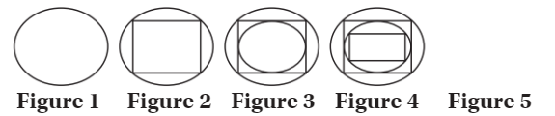
I can accurately measure angles with a protractor. 4MD5B
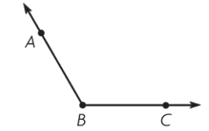 | 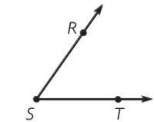
I can find unknown angles using addition and subtraction. 4MD7
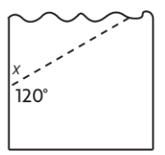 | 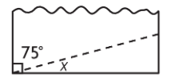
I can find the area and perimeter of polygons. 4MD3
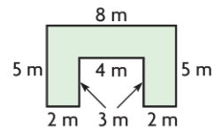  Area = ________ Perimeter=_________ | 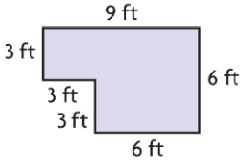  Area = ________ Perimeter=_________
Show work and solve
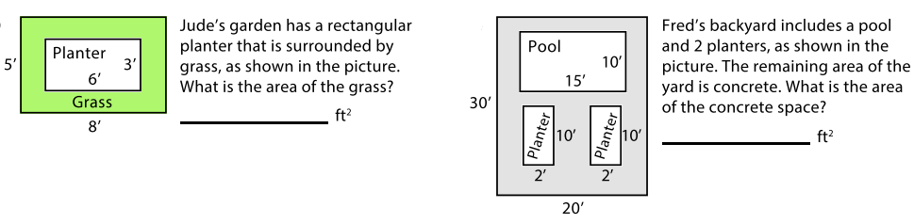

Show work and solve
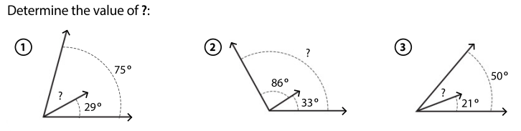
Show work and solve
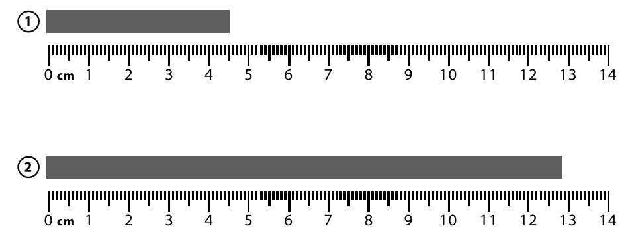
Measure and solve
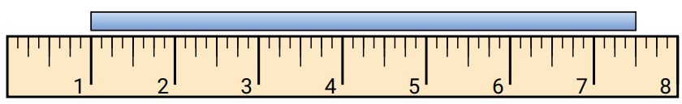
Solve
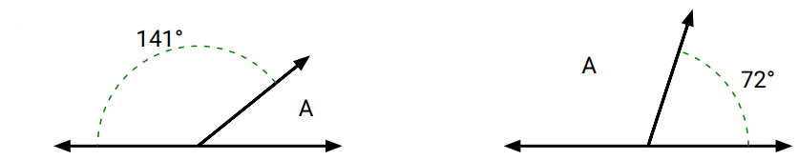

Draw a scalene triangle | Draw a quadrilateral
Draw a 115 degree angle | Draw a 45 degree angle
Draw a shape with one line of symmetry | Draw a shape with two lines of symmetry

