Time | 60 min = 1 hour | 24 hours = 1 day | 12months=1year | 52weeks = 1 year | 365 days = 1 year
Distance | 12 in = 1 foot | 3 feet = 1 yard | 10mm = 1cm | 100 cm = 1 m | 1000m = 1km
Weight | 16 oz = 1 lb | 2,000 lb = 1 Ton | 1,000 mg = 1 g | 1,000 g = 1 kg | 1,000 kg = 1 Ton
Volume | 1 cup = 8 oz | 2 cup = 1 pint | 4 cups = 1 quart | 4 qts = 1 gallon | 1,000 ml = 1 liter
METRIC SYSTEM: Germany CUSTOMARY SYSTEM: U.S.A.
I can name and LABEL lines, segments and angles using correct symbols. 4G1
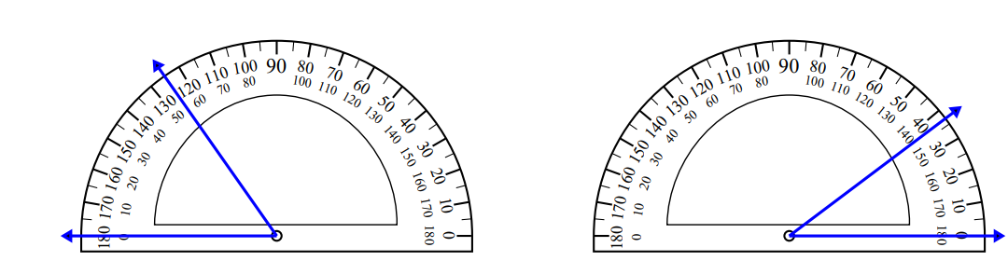
I can identify triangles based on angles. 4G2
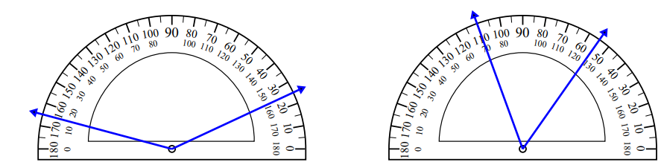
I can convert customary units of length (United States)
I can convert customary units of weight (United States)
I can convert customary units of volume (United States)
I can convert metric units of length (Germany)
I can convert metric units of mass and volume (Germany)
I can convert units of time
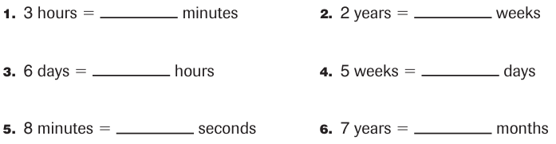
I can convert units of measurement
I can add and subtract units of mearsurement
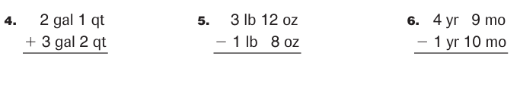
I can calculate elapsed time – show on a timeline
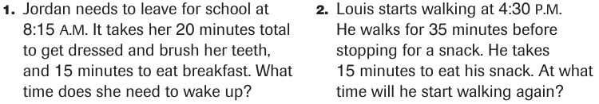

I can write in the correct label for each table
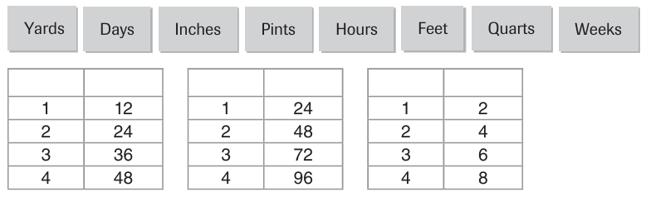
I can make a line plot graph
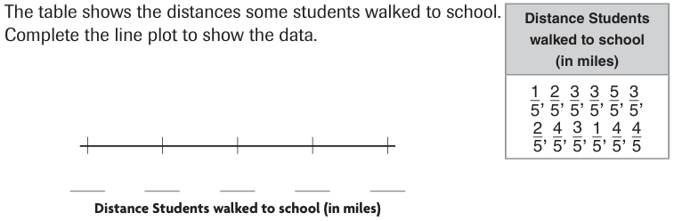

What is the distance between the longest walk and shortest? __________

How many students walked less than a mile to school? ____________
I can match common units of time
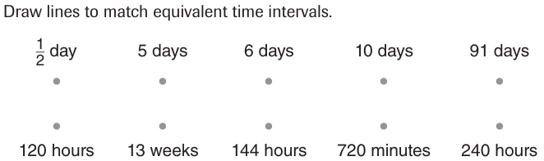
Place these letters on the metric ruler accurately
N = 7$\frac{6}{10}$ cm A = 54 mm I = 12 mm C = 2.6cm

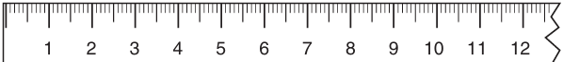
I can solve problems with units of measurement
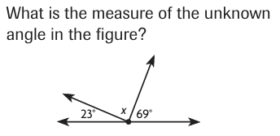  X = ______ |  |  | 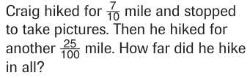  As a decimal, craig hiked _______ miles.
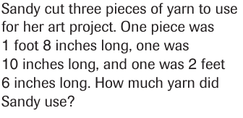  _____ feet ____ inches of yarn |  |  | 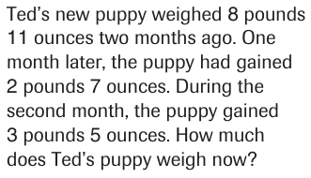  _____ lbs ____ oz
