Directions: Each picture is described in the textbook. Find the description and use it to help write a caption for the picture in your own words. Spelling and grammar count.

 | 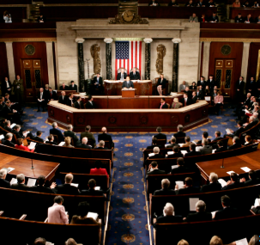
 | Congress
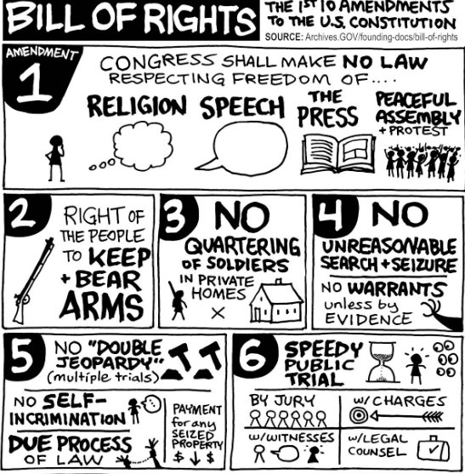 | 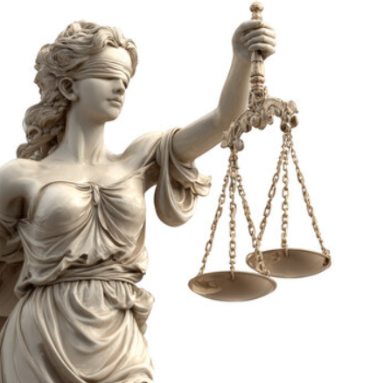

Directions: Each picture is described in the textbook. Find the description and use it to help write a caption for the picture in your own words. Spelling and grammar count.

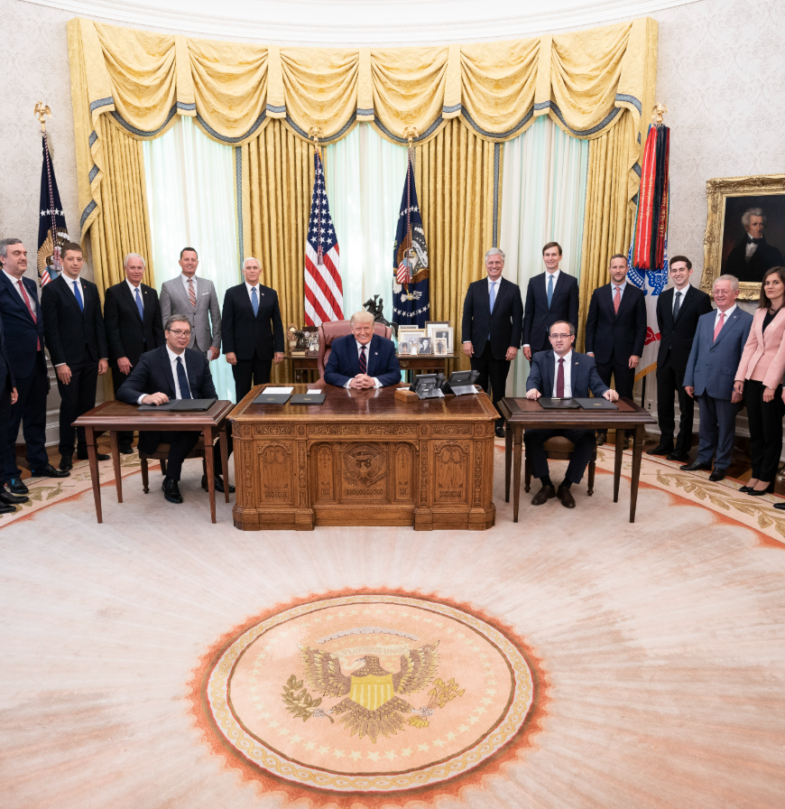 | 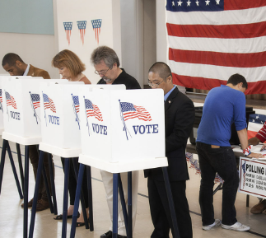
The Oval Office
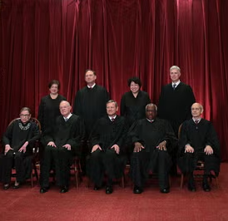 | 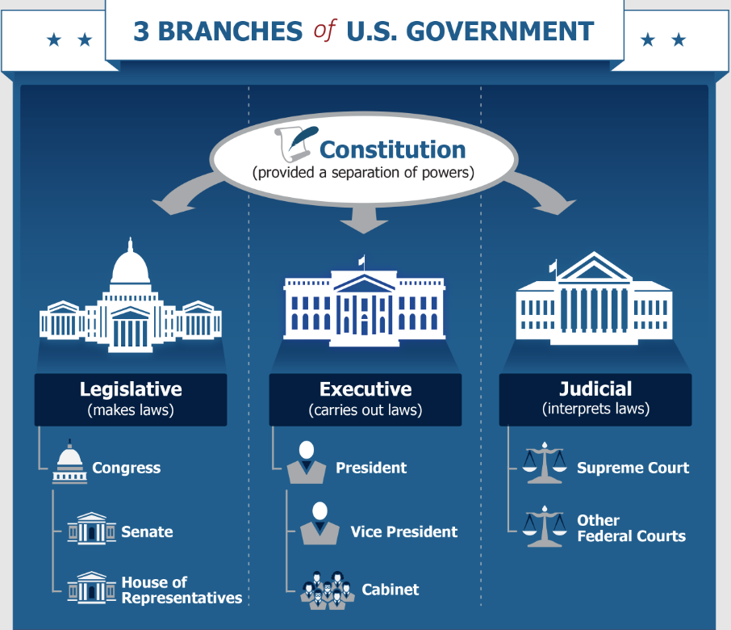
Supreme Court

